1. Grade Checker

Take a score as input and print the grade based on the following:

90+ : "A"

80-89 : "B"

70-79 : "C"

60-69 : "D"

Below 60 : "F"

here we used a basic if else statement to carry out marks and all.

Ans :- code –

grade = int(input("Enter your grades \n"))

if grade >= 90:

    print("you got A grade")

elif grade >= 80:

    print("you got B grade")

elif grade >= 70:

    print("you got C grade")

elif grade >= 60:

    print("you got D grade")

else:

    print("you got F grade")

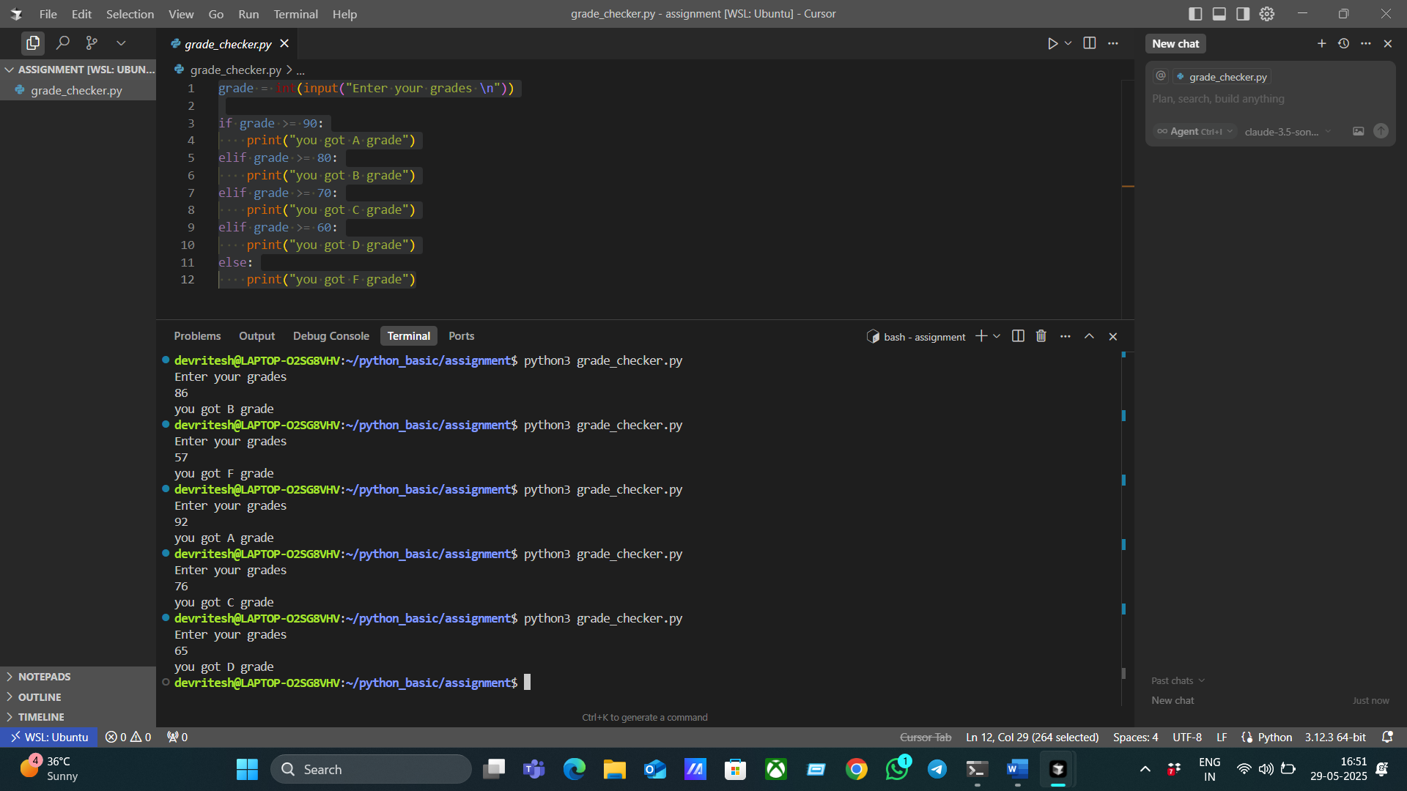

2 Student Grades

Create a dictionary where the keys are student names and the values are their grades. Allow the user to:

Add a new student and grade.

Update an existing student’s grade.

Print all student grades.

Used dictionary and basic operations. Using if else:

def main():

    student_grades = {}

    while True:

        print("\nMenu:")

        print("1. Add a new student and grade")

        print("2. Update an existing student's grade")

        print("3. Print all student grades")

        print("4. Exit")

        choice = input("Enter your choice (1-4): ")

        if choice == '1':

            name = input("Enter student name: ")

            if name in student_grades:

                print(f"Student '{name}' already exists with grade {student_grades[name]}. Use update option to change the grade.")

            else:

                grade = input("Enter grade for the student: ")

                student_grades[name] = grade

                print(f"Added student '{name}' with grade {grade}.")

        elif choice == '2':

            name = input("Enter student name to update grade: ")

            if name not in student_grades:

                print(f"Student '{name}' does not exist.")

            else:

                grade = input("Enter new grade for the student: ")

                student_grades[name] = grade

                print(f"Updated student '{name}' with new grade {grade}.")

        elif choice == '3':

            if not student_grades:

                print("No student grades to display.")

            else:

                print("Student Grades:")

                for student, grade in student_grades.items():

                    print(f"{student}: {grade}")

        elif choice == '4':

            print("Exiting program.")

            break

        else:

            print("Invalid choice. Please enter a number between 1 and 4.")

if __name__ == "__main__":

    main()

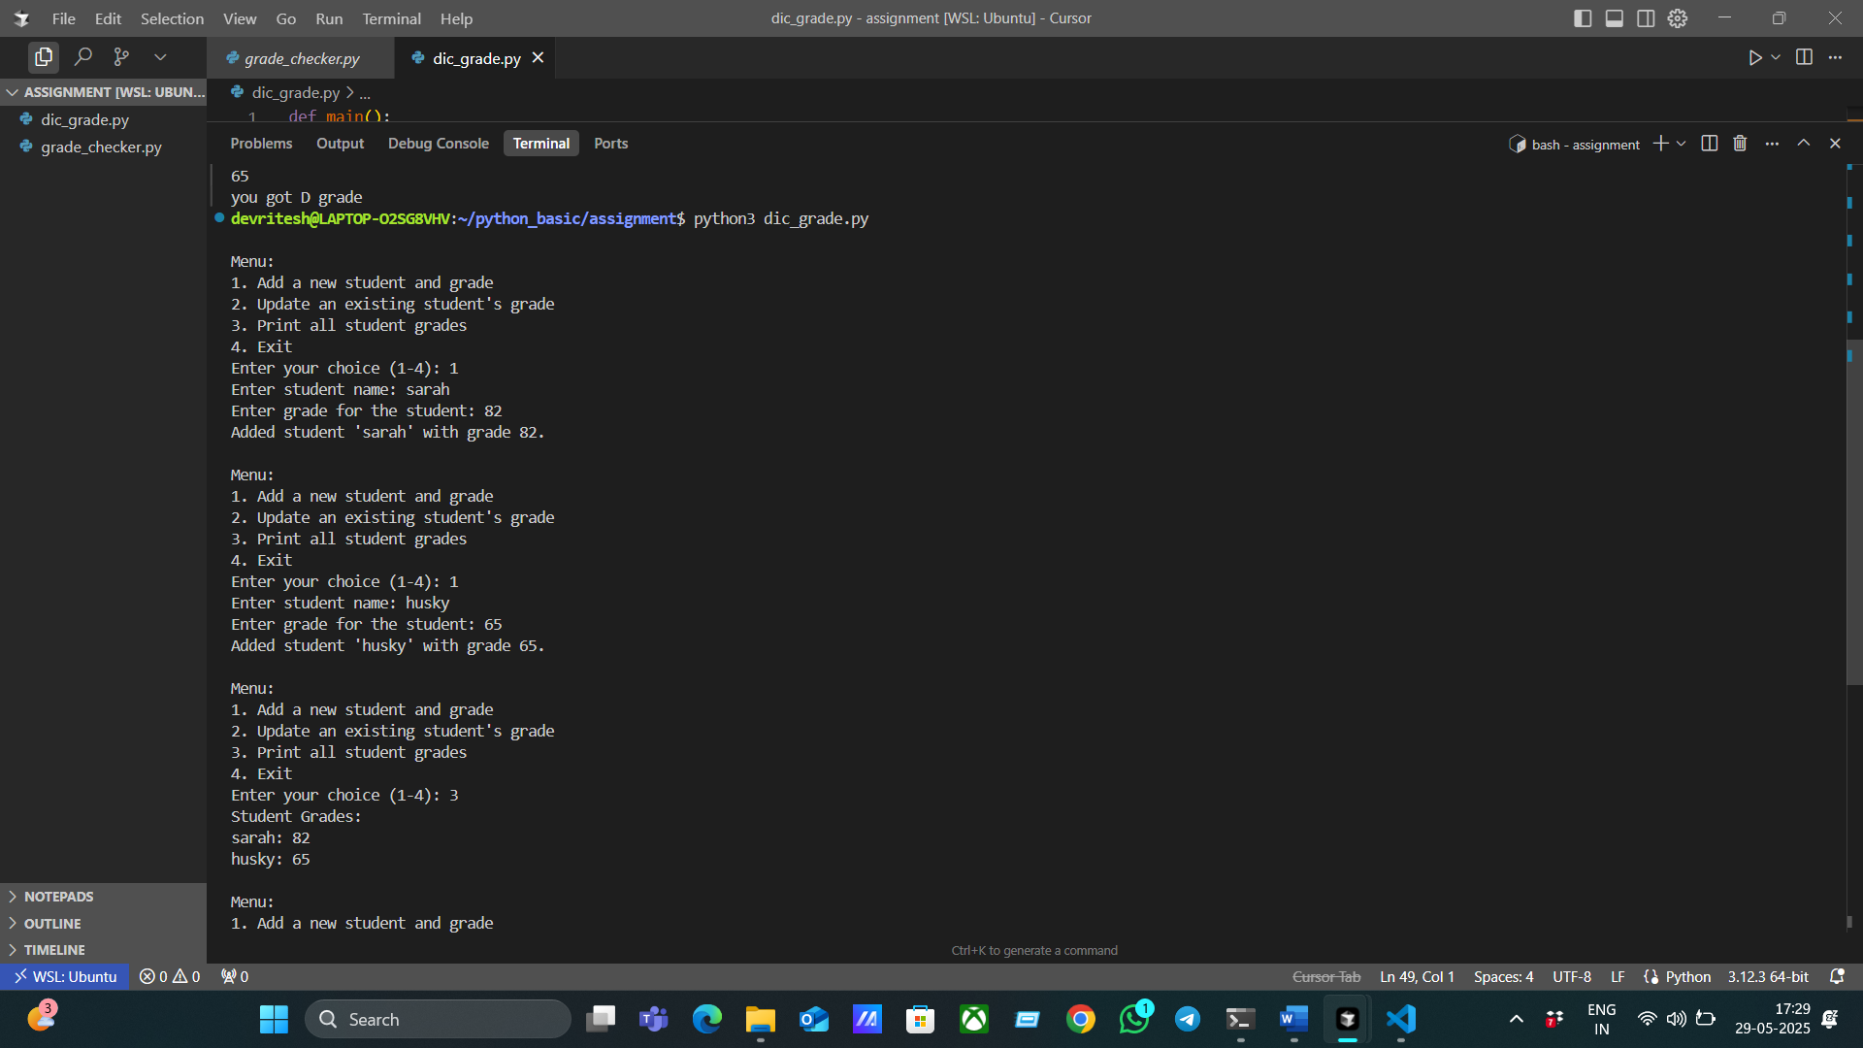

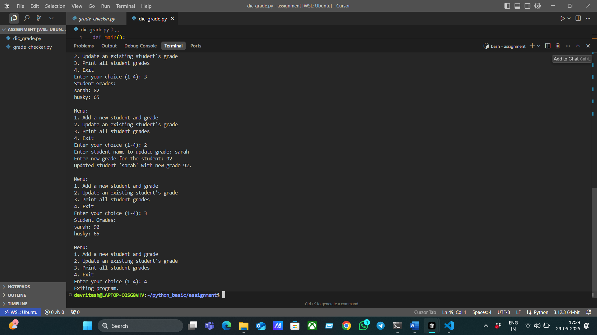

3. Write to a File

Write a program to create a text file and write some content to it.

Using file functions like write and open.

Ans :-

1. Ls
2. Touch bash.txt
3. f = open("bash.txt","w")
4. data = f.write("working with file handling commands\n")
5. data = f.write("This is the second line of text added to the file\n")
6. print(data)
7. f.close()

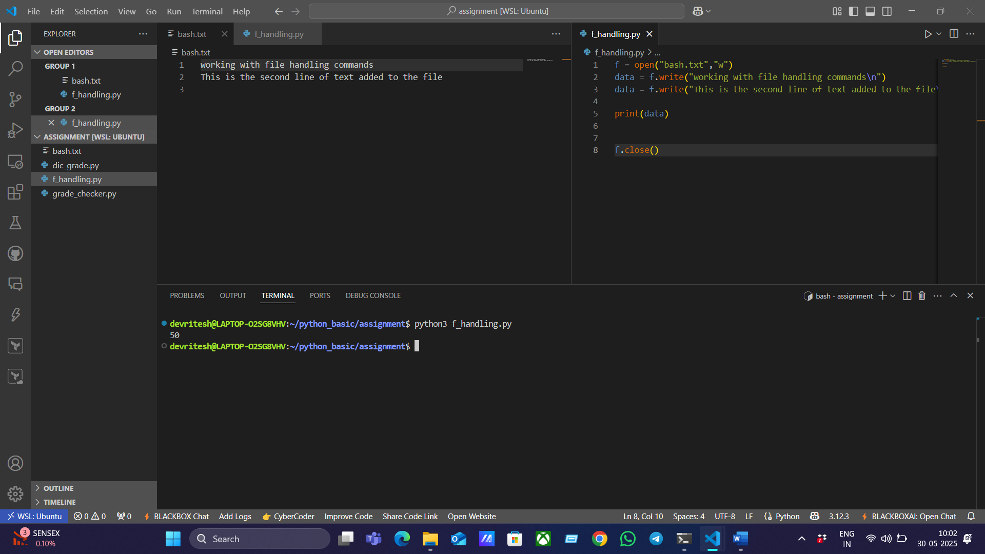

4. Read from a File

We used open in read mode and file.read to read and print to display.

Ans:-

1. ls
2. touch bash.txt
3. echo " heloo guys , i am adding text in this file"> bash.txt
4. Cat bash.txt

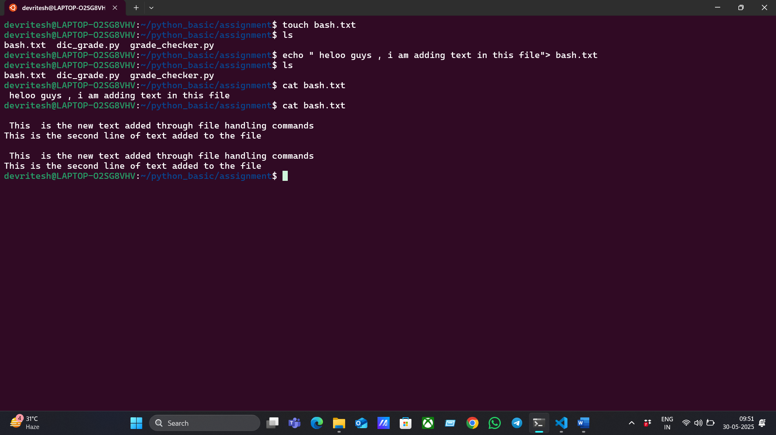

1. f = open("bash.txt","r+")
2. data = f.read()
3. print(data)
4. f.write("\n This  is the new text added through file handling commands \n")
5. f.write("This is the second line of text added to the file\n")
6. f.close()

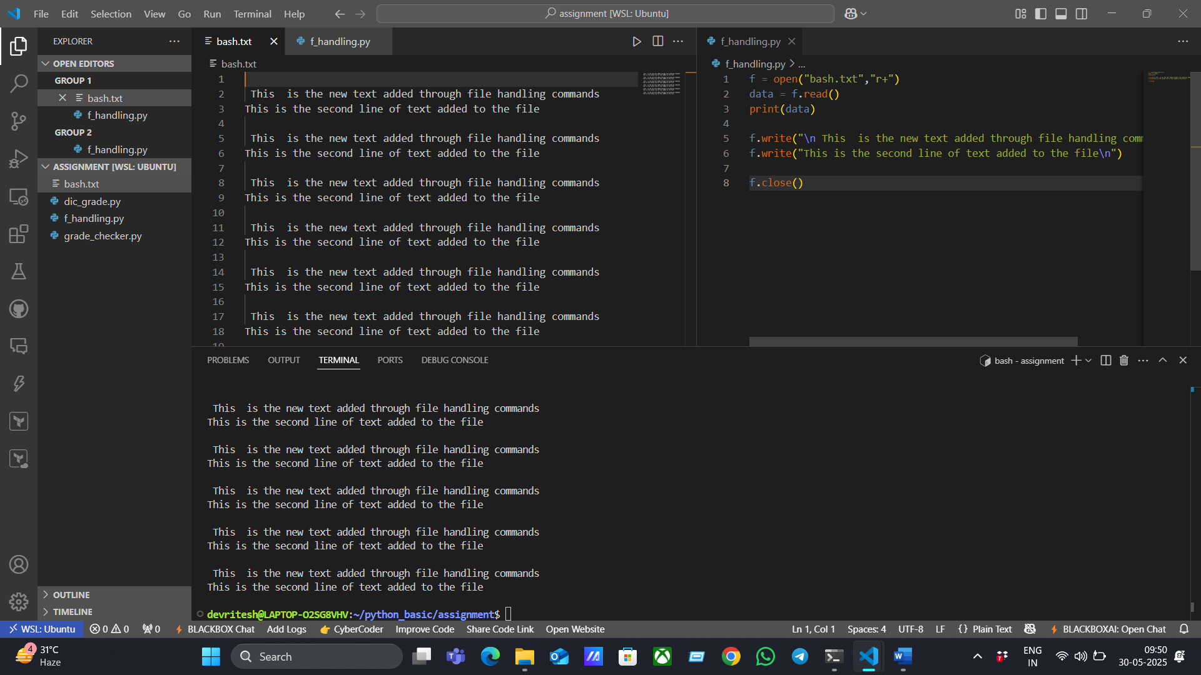

**Submission Guidelines -:** Attach Screenshots or command along with explanation and submit in doc(google doc or microsoft doc) format or share github link